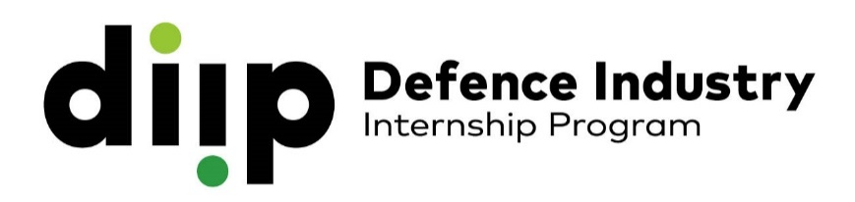

SUITABILITY STATEMENT

We suggest you structure your suitability statement in the following way:

Information about you, your educational background and engineering experience (if any).

What areas of engineering are you interested in? What are your career ambitions?

Why are you applying for a DIIP internship?

What about your preferred internship opportunities appeals to you?

What technical skills do you have that make you a good applicant for these internships?

What personal skills do you have that make you a good applicant for these internships?

Any final comments you would like to make.

